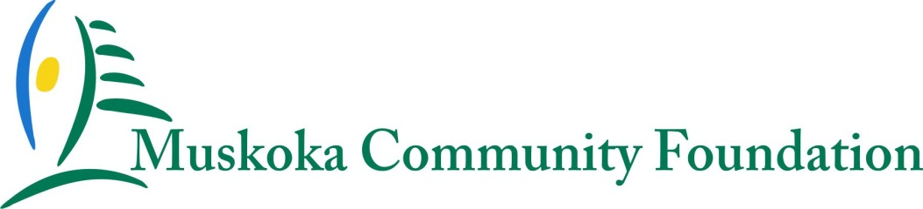

2015 MUSKOKA COMMUNITY FOUNDATION GRANT APPLICATION
‘The Spirit of Wasan Island Grants’ to build a Smart and Caring Muskoka

Inspired and excited by the Wasan Island symposium held in September 2014 and summarized in the Muskoka Community Foundation document ‘Building a Smart and Caring Muskoka’, Muskoka Community Foundation (MCF) is initiating an innovative granting approach for 2015. This granting opportunity is intended to extend the spirit and energy of the Wasan Island symposium into tangible action that will have immediate impact in Muskoka and will result in a high visibility project or projects being undertaken by a collaborative group of charities and other organizations.

Muskoka Community Foundation is inviting your organization to submit a proposal to undertake a collaborative project that would address an immediate need or challenge in Muskoka. It may be derived from an idea or suggestion mentioned at the Wasan Island symposium or it may be an original idea that embraces the spirit of building a smart and caring Muskoka.

Proposals must be submitted by March 13, 2015 at 4:00 p.m. and meet the granting criteria.
Granting Criteria
- The project must be a specific, tangible and doable project with a well-defined purpose that will result in an impact that continues the spirit and energy initiated at Wasan Island and contributes to building a smart and caring Muskoka (as described in the summary of the Wasan Island symposium and entitled ‘Building a Smart and Caring Muskoka’).
- The project must involve a collaboration of more than one organization that is led by a charity. The participating organizations could include those that attended Wasan Island or could be expanded to include other Muskoka charities or not-for-profit organizations. The collaboration could also include other community groups or municipalities.
- The outcome of the project must have high visibility that benefits all members of the collaborative group and the Muskoka Community Foundation.

- The project must qualify as being charitable and benefit a community or communities in Muskoka.

- The project must also be completed in 2015.
Funding Available:
- A total of $22,000 in funding is available for one modest project or multiple projects in 2015. Multiple projects with smaller budgets may be given preference, if greater impact can be achieved.

- Additional funding or in kind contributions from other sources may be added to the Muskoka Community Foundation funding in order to expand the scope or impact of the project. Any such additional funding available or proposed must be identified in your submission.

Submission Evaluation:
Muskoka Community Foundation will evaluate and select the project or projects that best meet the granting criteria. A granting committee will be established for this purpose. Additional information or details may be requested to assist the granting committee in making a decision. If Muskoka Community Foundation is not satisfied that the submissions meet the granting criteria, it may issue an invitation for amendments or decide not to proceed to fund a project. All decisions by the Muskoka Community Foundation board are final and not subject to review.

Implementation:
Media relations will be promoted throughout the course of the project. Media related to each project will be undertaken jointly by the lead charity and Muskoka Community Foundation. It will identify the contribution and role of Muskoka Community Foundation and the lead charity as well as the collaboration members.

Muskoka Community Foundation will make a grant that will flow to the lead charity for each project selected. The lead charity must be a registered charity as defined by Canada Revenue Agency (CRA) that is located in and providing services in the District of Muskoka. Depending on the proposal or proposals accepted, the funds may be distributed in phases over the course of the project.

The lead charity will be responsible for the coordination, administration and implementation of each project as well as for joint media releases or events undertaken jointly with Muskoka Community Foundation. Recipients will be required to keep the successful grant application confidential until it is announced to the community.

The progress of each project must be reported to Muskoka Community Foundation throughout the project implementation. The lead charity will be responsible for reporting the results of the project regularly to Muskoka Community Foundation during the course of the project. Upon completion of the project, the lead charity will be required to provide a written summary of the grant’s impact.

THE APPLICATION PROCESS
Please complete and sign your application in the space provided and e-mail your completed application to margaret@muskokacommunityfoundation.ca by 4:00 pm Friday, March 13, 2015.

Your submission must include:
- The completed and signed application form
- A copy of the lead charity’s last annual Financial Statements (audited or unaudited)
- Background about each organization participating in the project.

We will acknowledge that we have received your application and will contact you if we need additional information.

By signing this application the applicant expressly acknowledges and consents to release of information as required by Muskoka Community Foundation regarding applications received, decisions made and other matters relating to the granting process and in accordance with the Personal Information Protection and Electronic Documents Act.

2015 MUSKOKA COMMUNITY FOUNDATION GRANT APPLICATION
‘The Spirit of Wasan Island Grants’ to build a Smart and Caring Muskoka

APPLICANT INFORMATION
Name of the Designated Lead Charity
Charitable Registration Number
Address
City, Province, Postal Code
Contact Person
Title
Telephone
Email
Website address

Name and type of organizations participating (charity, NFP etc.) | Contact Person, Title and Email | Address, Phone Number and Website

Amount requested to complete the project $

Please indicate the geographic area(s) of Muskoka impacted by this grant request:
□ District of Muskoka | □ Town of Gravenhurst | □ Town of Huntsville
□ Township of the Muskoka Lakes | □ Township of Lake of Bays | □ Township of Georgian Bay
□ Town of Bracebridge | □ Other (please identify):

Please describe your project and the expected outcomes:

Explain how the project satisfies the granting criteria and will contribute to creating a smart and caring Muskoka?

Describe the purpose, background and role of each organization in your collaboration

Provide a project budget and identify any supplementary funding or in kind contributions

Provide a project timeline with important milestones and the date of completion

Explain how the success of the project will be measured and reported to Muskoka Community Foundation?

Signature of person completing application on behalf of the lead charity | Position | Date

