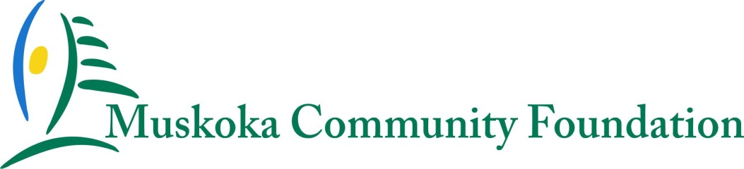

2018 Smart & Caring Muskoka Fund Grant Application

Muskoka Community Foundation (MCF) is inviting registered charities in the District of Muskoka to apply for grants of up to $3,000 from our Smart & Caring Muskoka Fund for proposals of projects/initiatives that will contribute to building smart and caring communities in Muskoka. Your proposal for a Smart & Caring Muskoka grant can be for a new or existing program that will benefit Muskoka and can be used in concert with other funding opportunities.

This year’s granting theme is “Community”. Priority will be given to proposals that most effectively:
- Build vibrant and healthy communities
- Promote inclusive engagement of many community members
- Encourage community participation and interaction
- Enhance community wellness and quality of life

The Smart & Caring Muskoka Fund is a community fund created by MCF in November 2012 in response to Governor General David C. Johnston’s challenge to all Canadians to “imagine our country as it could be...a smart and caring nation, where all Canadians can succeed, contribute, and develop their talents to their fullest potential”. The Smart & Caring Muskoka Fund is a pooled community fund that is continuing to grow as a result of the gifts of a wide variety of generous donors. Each year this fund enables MCF to address a wide range of outstanding issues and challenges that face the region.

CONDITIONS
- Applicants must be a registered charity as defined by Canada Revenue Agency (CRA) and provide services in the District of Muskoka.
- The proposed work must qualify as charitable and benefit a community or communities in Muskoka.
- Projects must have a well-defined purpose and be undertaken within a specific time period.
- All successful applicants will be required to provide a written summary of the grant’s impact not later than 60 days after the completion of their project/initiative.
- Grants from the Smart & Caring Muskoka Fund will not be given:
- to cover operating deficits or retire debts
- to provide endowment funds
- for sectarian, religious, or political purposes
- to individuals.
- Approval of a grant by MCF does not commit the Foundation to future funding.
- Celebrations and Fundraising activities will not be supported by a Smart & Caring Muskoka Fund Grant.

THE APPLICATION PROCESS
Applications will be accepted beginning on August 13, 2018. Please e-mail your completed and signed application form to Lynn DeCaro, Executive Director, at info@muskokacommunityfoundation.ca by 5:00 pm Friday, September 28, 2018.

Applicants must submit the following documents with their application:
- The completed and signed application form
- A list of your current Board of Directors
- A budget for the proposed project/ initiative
- A copy of your charity’s last annual financial statements (audited or unaudited).

By signing the application, the applicant expressly acknowledges and consents to release of information as required by MCF regarding applications received, decisions made and other matters relating to the granting process and in accordance with the Personal Information Protection and Electronic Documents Act.

In a situation where MCF decides to extend the submission deadline or clarify the request for grant proposals, notice will be provided to all of the organizations that have contacted MCF about this grant making opportunity, to Muskoka charities and on the MCF website.

Following the submission deadline, MCF will acknowledge that we have received your application and will contact you if additional information is required.

Our decision will be provided to all applicants by Friday, October 26, 2018. All decisions by the MCF are final and not subject to review.

Recipients will be required to keep a successful grant application confidential until it is announced by MCF. Grants will be announced to the community at a cheque presentation ceremony during the National Philanthropy Day Celebration at the District Council Chambers at 9:30 am Thursday, November 15, 2018.

All successful applicants will be asked to publicly acknowledge and recognize MCF’s support of their initiative and partner with MCF to share the good news about their grant and initiative. Successful applicants will also be required to submit a written summary of the grant’s impact at the conclusion of the project/initiative.

2018 Smart & Caring Muskoka Fund Grant Application Form

APPLICANT INFORMATION
Name of Organization
Charitable Registration Number
Address
City, Province, Postal Code
Project/initiative Lead & Contact Person
Title
Telephone
Email
Website address

Amount requested from MCF’s Smart & Caring Muskoka Fund: $

Please indicate the geographic area(s) of Muskoka impacted by this grant request:
□ Bracebridge | □  Gravenhurst | □ Huntsville
□ Township of the Muskoka Lakes | □ Township of Lake of Bays | □ Township of Georgian Bay
□ District of Muskoka | □ Other (please explain):

Please explain your initiative (including purpose & timeline) and describe how this funding will build vibrant & healthy communities, promote inclusive engagement, encourage community participation and interaction and enhance community wellness & quality of life:

Describe how the funding will be used and provide a detailed project/initiative budget (Please include all in-kind donations and dollar amounts received from other funding partners)

Explain how will the success of your project/initiative be measured?

Describe how you will recognize the funding provided by MCF :

Signature of the organizational signing authority | Position | Date

